File IO Demo

1. Start our program
   1. Start Visual Studio
   2. Create a new empty C++ project:
   3. Call it “FileIODemo”, pick the desktop as the location and click OK.
   4. Click on Source Files and Add|New Item:

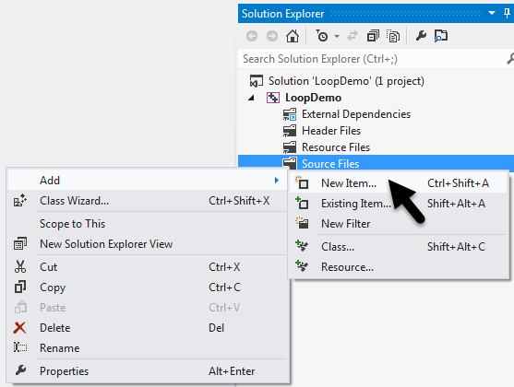

* 1. Select Visual C++, C++ File (.cpp), call it “FileIODemo”, then click “Add”:

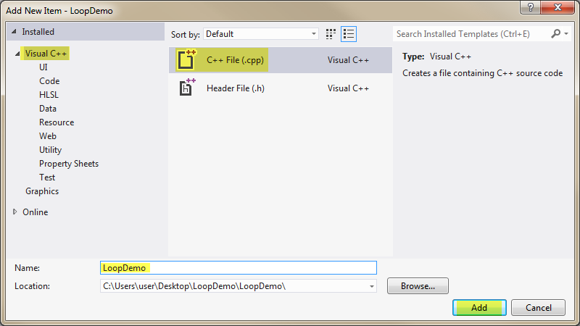

* 1. Enter the following code to start our program:

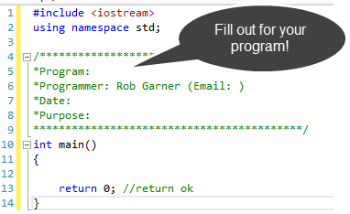

# Writing to a file:

1. Add the following code:

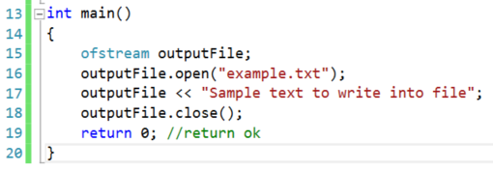

1. Run it with Ctrl-F5:
2. You won’t see any output. Instead open the project by right clicking the project n Solution Explorer and selecting Open Folder in File Explorer:

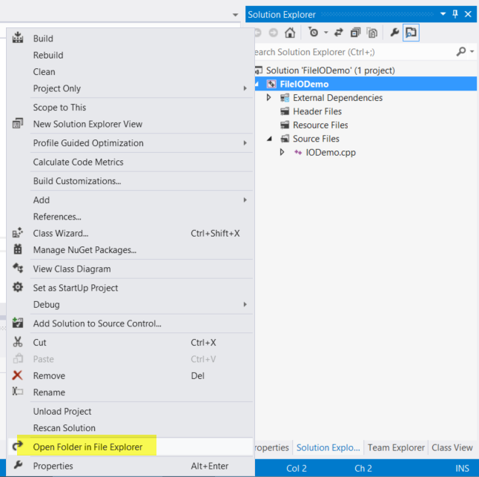

1. Open example.txt in notepad:

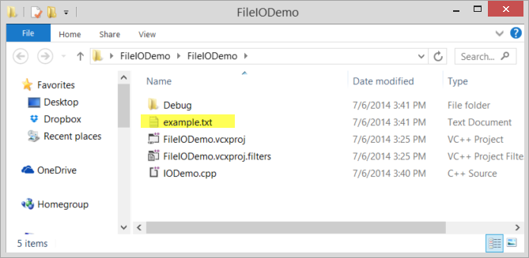

1. Notice the text from our code is in the text file:

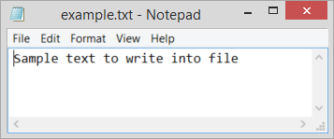

1. Note that if the file cannot be opened this program will fail.
2. Test this by changing the file name to something like “T:example.txt”. This won’t open unless you have a drive called T.
3. If you try this you won’t get an error but the file will not be opened and created.
4. To fix this, change the code to:

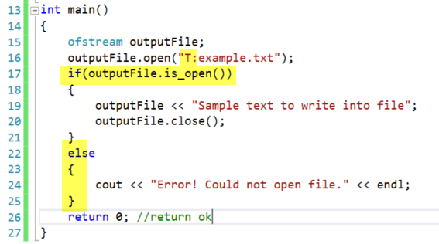

1. Try the program with Ctrl-F5. Notice that we include a file name that can’t be opened in order to test the else branch. When run you should get the error message:

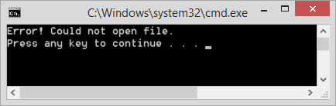

1. Now that we know that the error code works lets put in a file name that works:



1. Delete the example.txt file then run with Ctrl-F5. Example.txt should reappear.
2. Make the save file code a function:
3. Change the code to:

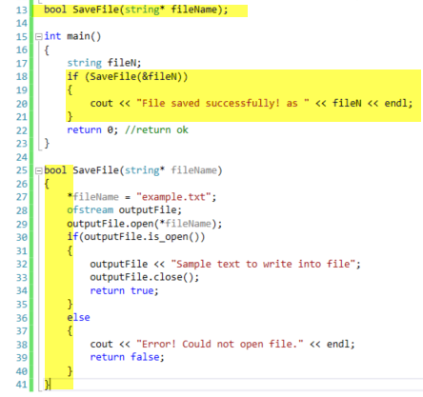

1. Notice that we pass a filename in by pointer. This is parameter is not used to set the file name. Instead it is used in this case to pass the file name back to the calling method.
2. Run it with Ctrl-F5:

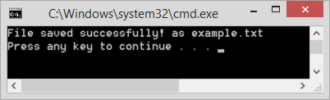

# Add a timestamp:

1. Add #include <ctime> at the top of your code.
2. Add the following code:

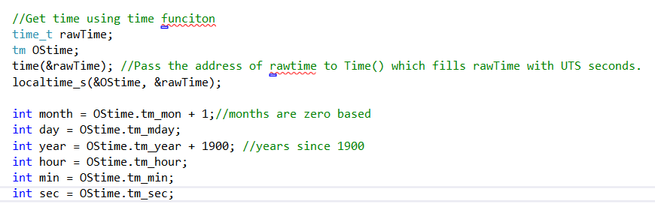

1. Notice that rawTime is a time_t object and OStime is a tm object. These are new types that we get from the cTime library.
2. Next in main add:



1. Try the program with Ctrl-F5 and look at “example.txt” notice that the time stamp has now been added.

# Add Timestamp Method 2

1. Another method is to use char arrays:
2. Add the following code:

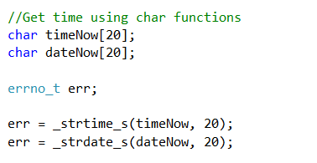

1. Add the following code to main:



1. Try the program with Ctrl-F5 and look at “example.txt” notice that the second time stamp has now been added.

# Move code into Functions

1. Our main program is now getting a bit crowded let’s move some of the code into functions:
2. Add the following function:

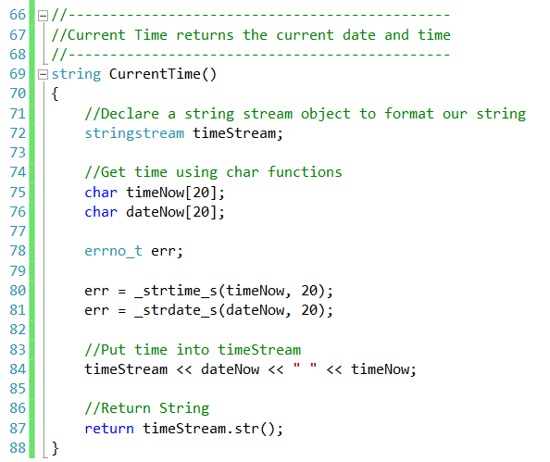

1. Next lets move the save code to another function:

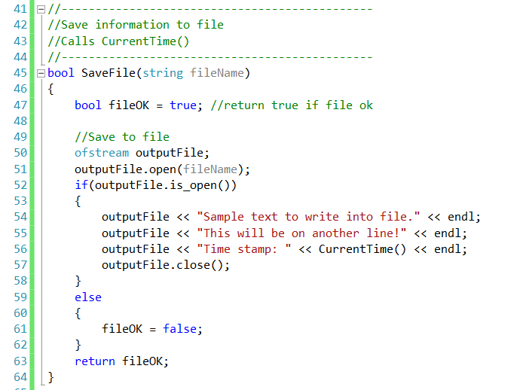

1. Notice that it calls our CurrentTime function on line 56 to get the time.
2. Make sure the function prototypes are declared above main:



1. Change the code in main to:

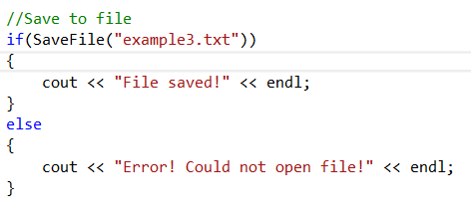

1. Try the program with Ctrl-F5 and look at “example.txt”.

# Read a Text File

1. Add the following function:

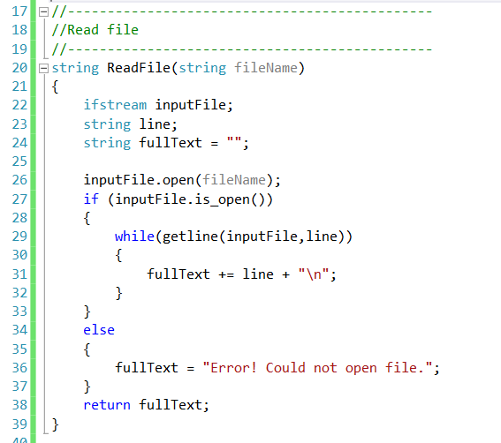

1. Don’t forget to add the function prototype to the top of the program.
2. In main call it:

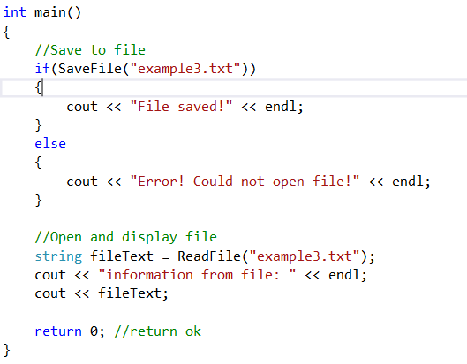

1. Notice that we call ReadFile to get the text from the file into a variable called fileText. This variable is then displayed with cout to show what is in the file.
2. Try program with Ctrl-F5. Notice that it successfully opens and displays our file: